Use Case Diagram

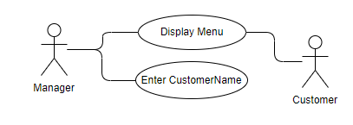

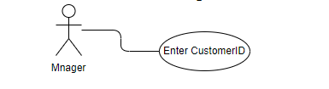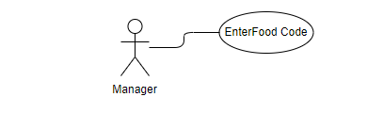

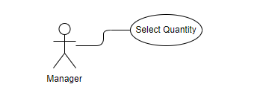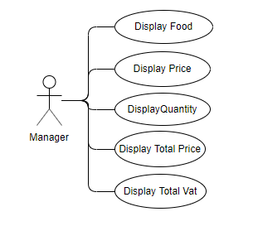

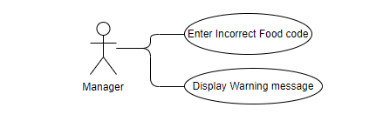

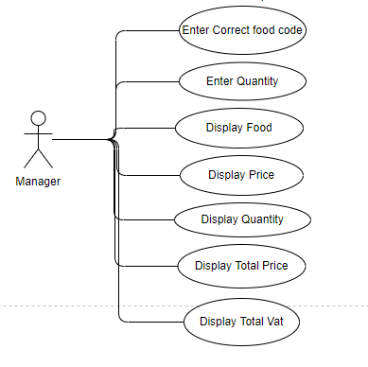

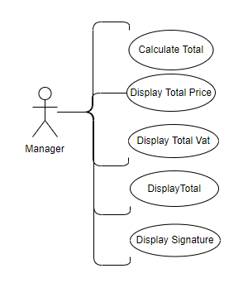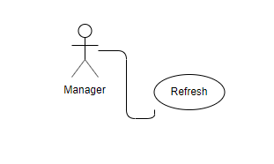

Use Case Description

|  |  |
| --- | --- |
| **USE CASE** | **Description** |
| Display Menu | The manager open the system and it display menu of the restaurant. |
| Enter Customer Name | The manager of the restaurant enter the customer name. |
| Enter Customer ID | The manager of the restaurant enter the customer ID. |
| Enter Food Code | The customer choice food code from menu.  The manager enter those food code |
| Select Quantity | The customer select quantity for all selected food.  The manager enter the quantity. |
| Display Food | The system display all selected food name. |
| Display Price | The system display all selected foods price individually. |
| Display Quantity | The system display all selected foods quantity individually. |
| Display Total Price | The system display all selected foods price individually which depend on quantity. |
| Display Total Vat | The system display all selected foods vat individually which depend on quantity. |
| Enter Incorrect Food Code | The manager enter incorrect food code. |
| Display Warning message | The system display warning message for incorrect food code. |
| Calculate Total | The system calculate total bill with vat for all selected food code. |
| Display Total | The system Display total bill with vat for all selected food code. |
| Refresh | The manager enter “M” to go main menu. |
|  |  |
|  |  |